Assignment 4

Q 1. WAJP to add two numbers

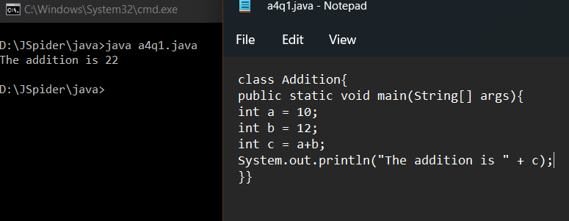

Q 2. WAJP to concat number and string

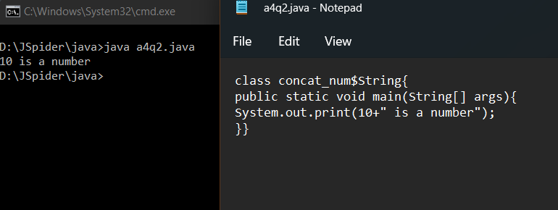

Q 3. WAJP to concat floating number and string

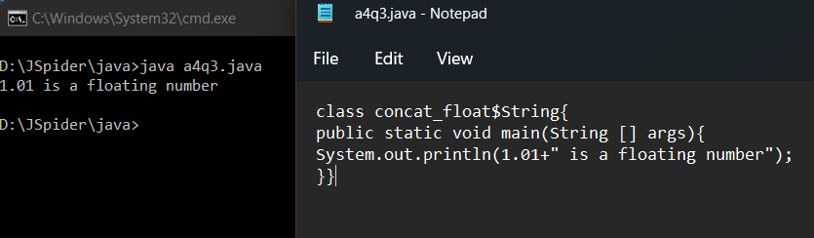

Q 4. WAJP to concat integer and character

Q 5. WAJP to concat character and string

Q 6. WAJP to concat int, character, boolean and string type data

